Experiment No. 10

Title: Observation of High Pass and Low Pass Filter Characteristics of RC and RL Circuits

Objective:
Many electrical circuits contain filters, which separate electric signals on the basis of their frequency contents. Filters are characterized by their frequency response as well as phase relation between input and output signals. In this experiment we will study low pass, high pass and band pass filters.

Theory

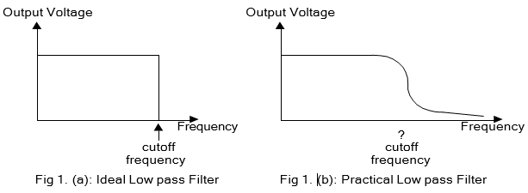
An ideal low pass filter passes all signals below a certain frequency which is termed as the cutoff frequency for that filter. In other words, the output signal amplitude will be zero if we feed the filter with an input signal that has frequency greater than its cutoff frequency. For signals with lower frequency the output signal amplitude will remain unaffected. This is true only for ‘ideal filter’ and the frequency response curve for ideal filter looks like Fig 1 (a). But for a practical filter the amplitude near the cutoff does not change instantly rather it follows a decreasing nature as shown in Fig 1 (b). Thus, for a practical filter we need to define cutoff frequency in different way. Some of the definitions for cutoff frequencies are given below:

What is cutoff frequency?
1. When our frequency response curve is given in terms of ‘voltage vs. frequency’: “cutoff frequency is the point at which the voltage level of the signal falls “1 /√2 or 0.707” times from its maximum value provided that the input signal amplitude remains same for all frequencies.”

2. When our frequency response curve is given in terms of ‘signal power vs. frequency’: “cutoff frequency is the point at which the power level of the signal falls “1/2 or 0.5” times from its maximum value.”

3. When our frequency response curve is given in terms of ‘gain vs. frequency’: “cutoff frequency is the point at which the gain of the signal falls “1 /√2 or 0.707” times from its maximum value.”

4. When our frequency response curve is given in terms of ‘gain (in db) vs. frequency’:
“cutoff frequency is the point at which the gain (in db) of the signal falls “-3db” from its maximum value.”

A simple first order RC low pass filter is shown in figure 2. Gain of this filter is given by:

$$A_{v}=\frac{v_{o}}{v_{i}}=\frac{1}{jωC (R+jωC)}$$

where $ω_{c}$ is the corner or cutoff frequency? For our low pass filter, cut off frequency,

$$ω_{c}=\frac{1}{RC}$$

An ideal high pass filter – blocks all signals below its cutoff frequency but passes all signals above cut off with no attenuation. A simple first order RC high pass filter is shown in figure 3. The gain of this filter is:

$$A_{v}=\frac{R}{(R+jωC)}$$

And its corner frequency $ω_{c}$ is also $\frac{1}{RC}$ Figure 4 shows a second order band pass filter, which is designed to pass all signals whose frequency lie within a specific band. Therefore, it has two cutoff frequencies $ω_{CL}$ below which the filter blocks signals and $ω_{CH}$ above which it again blocks signals. Thus, the filter has a pass band between these two frequencies and the frequency $ω_{o}$ is the mid band frequency where the gain is maximum. The gain of this filter is given by
$$A_{v}=\frac{\frac{1}{jωR_{1}C_{1}}}{1+\frac{1}{jω}(\frac{1}{R_{1}C_{1}}+\frac{1}{R_{2}C_{2}}+\frac{1}{R_{1}C_{2}})+\frac{R_{1}C_{1}R_{2}C_{2}}{{(jω)}^{2}}}$$

Apparatus
Resistance: 1. 10 Ω ............................2 pc
Capacitor: 2. 0.22µf………………..1 pc
0.1 µf………………...1 pc
1µf…………………...1 pc
2.2µf..………………..1 pc

3. Oscilloscope
4. Oscilloscope Probe…………………………………2 pc
5. Signal Generator…………………………………… 1 pc
6. Signal Generator Probe……………………………...1 pc
7. Multi-meter………………………………………….1 pc
8. Bread Board…………………………………………1 pc
9. Wires for connection

Circuit Diagram:

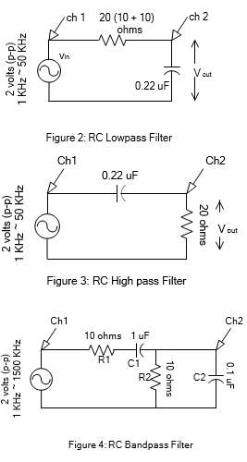

Procedure

1. Construct the circuit of figure 2. Connect Vin to channel 1 and Vout to channel 2 of the oscilloscope.
Adjust the signal generator to 2 volts (p-p) & 100 Hz.
2. Measure Vin, Vout and phase difference between them using oscilloscope and fill up the table. Repeat for each of the frequencies shown in the table.

Note: Adjust the amplitude of source (channel 1) each time to 2 volt (p-p).

Table 1
Frequency, f  ( Hz ) | Output Voltage,  Vout | Gain ,  Vout / Vin
50 ( 20ms)
333 ( 3ms )
500 ( 2ms )
1000 ( 1ms )
5000 ( 0.2ms )
20000 ( 50 us )
33333 ( 30 us )
50000 ( 20 us )
100000 ( 10 us )

3. Now construct the circuit of figure 3 and repeat steps 1 and 2 and fill up table 2.

Table 2

Frequency, f  ( Hz ) | Output  Voltage,  Vout | Gain ,  Vout / Vin
10000 ( 0.1ms)
20000 ( 50 µs )
40000 ( 25 µs )
50000 ( 20 µs )
66666 ( 15 µs )
400000 ( 2.5 µs )
666666 ( 1.5 µs )
1000000 ( 1 µs )

Report

1. Determine the theoretical corner frequencies of filter 1, 2 the frequency

2. Plot the gain, A_{V} vs frequency curves for filters on separate sheets. Use semi-logarithm graph paper.

3. Determine the cut-off frequencies from the graphs and compare these with the theoretical values.

Experiment No. 11

Title: Observation of Faraday’s law of Electromagnetic Induction and physical demonstration.
Objective:
The objective of this experiment is to investigate Faraday's Law of Electromagnetic Induction and Lenz’s law, and explore the relationship between the magnetic field and the induced electromotive force (EMF) in a conductor.

Theory:
The phenomenon of electromagnetic induction is a fundamental concept in physics, and it has applications in various fields such as electrical engineering, power generation, and transmission, among others. Electromagnetic induction is the process of generating an electric field in a conductor by varying the magnetic field surrounding it. Michael Faraday first discovered this phenomenon in the 19th century, which led to the development of modern electrical devices such as generators, transformers, and motors.

Faraday's Law of Electromagnetic Induction describes how a changing magnetic field can generate an EMF across a conductor. The induced EMF (ε) is directly proportional to the rate of change of the magnetic field (dB/dt), and the number of turns in the conductor (N).

Mathematically, Faraday's Law can be represented as:
ε = -N(dΦ/dt)

where ε is the induced EMF, N is the number of turns in the conductor, and dΦ/dt is the rate of change of the magnetic flux through the conductor.

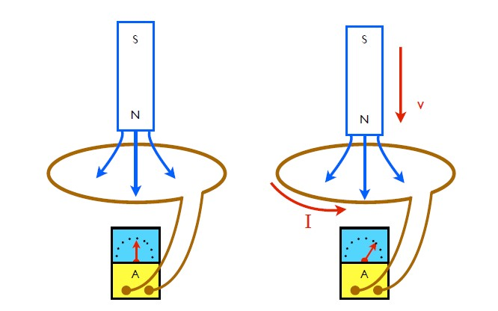

Fig.11 Demonstration of Faraday's Law
In this experiment, we will explore the relationship between the magnetic field and the induced EMF in a conductor, as discovered by Michael Faraday. We will investigate the principles of electromagnetic induction and understand how a changing magnetic field can generate an electric field and an EMF across a conductor.
Equipment Needed: The equipment required for this experiment includes a coil of wire, a magnet, a power supply, a voltmeter, and an ammeter.

Procedure:
- Connect the voltmeter with the coil of wire.
- Move the magnet back and forth across the coil to create a changing magnetic field.
- Measure the voltage across the coil using the voltmeter.
- Repeat step 2 and 3 with coil of wire having different turn number.
- Record the data and repeat the experiment several times to obtain accurate readings.
Assignment:
- Explain the reason behind the change in voltage rating with the change of number of turns.
- How time changing magnetic field affect the induced voltage?
- Describe Lenz’s law and explain how it is related to Faraday’s Law of Electromagnetic Induction.

Experiment No. 12

Title: Observation of the Operation of step-up and step-down Transformer, DC Generator, and DC motor

Objective:
To learn basic understanding of Step-Up Transformer
To learn basic understanding of Step-Down Transformer.

Theory
A transformer is a static device that change A.C voltages from one level to another level using the phenomenon of electromagnetic mutual induction. a current carrying coil always
create field around it which is also associated with the coil placed with in the region of electrified coil as current changes flux through secondary also changes this phenomenon is called mutual induction. In Step-down transformer number of turns in secondary are more than number of turns in primary coil in such a transformer Vp is greater than Vs voltage.

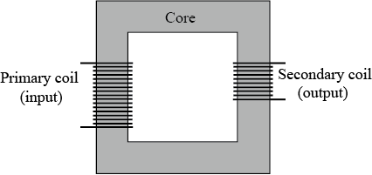

Fig.12.1 Transformer

Step-Down Transformer
In Step-Down transformer number of turns in secondary are less than number of turns in
primary coil. In such a transformer Vp is greater than Vs. 𝑉s < 𝑉p and 𝑁s < 𝑁p

Step-Up Transformer
In Step-Up transformer number of turns in secondary are more than number of turns in
primary coil. In such a transformer Vs is greater than V. 𝑉s > 𝑉p and 𝑁s > 𝑁p

Equipment/Components:
1. Transformer……………1pc
2. Function generator……..1pc
3. Power supply (220V)
4. Digital Multi-meter…….1pc

Procedure:

- Set up the experiment by connecting the step-down transformer to the AC power source. Make sure the power source is set to the appropriate voltage level for the transformer.
- Connect the multimeter to the secondary coil of the transformer. Set the multimeter to measure voltage at AC mode.
- Turn on the AC power source.
- Observe the voltage reading on the multimeter. It should be lower than the input voltage.
- Turn off the AC power source.
- Record your observations and measurements in your lab notebook.
- Repeat the experiment with different input voltages and record your observations.
- Analyze your data and draw conclusions about the behavior of the step-down transformer.

Table for Step down transformer

Number of Observation | Vp | Vs | (Ns/Np) *Vp=Vs | Error

- Set up the experiment by connecting the step-up transformer to the AC power source (Signal generator). Make sure the power source is set to the appropriate voltage level for the transformer.
- Connect the multimeter to the secondary coil of the transformer. Set the multimeter to measure voltage at AC mode.
- Turn on the AC power source (signal generator).
- Observe the voltage reading on the multimeter. It should be higher than the input voltage.
- Turn off the AC power source.
- Record your observations and measurements in your lab notebook.
- Repeat the experiment with different input voltages and record your observations.
- Analyze your data and draw conclusions about the behavior of the step-up transformer

Table for Step-Up Transformer

Number of Observation | Vp | Vs | (Ns/Np) *Vp=Vs | Error

Working Principle of DC motor

A simple DC (direct current) motor converts electrical energy into mechanical energy. It consists of two basic parts: a stationary part called the stator and a rotating part called the rotor. The rotor is a rotating component that contains a coil of wire. The stator is stationary component that contains a permanent magnet or a set of electromagnets.

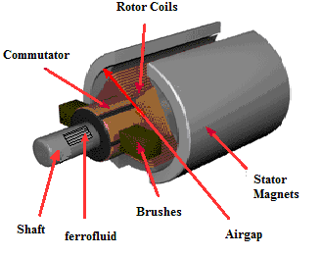

Fig.12.2 Internal structure of a permanent magnet DC motor

The working principle of a DC motor is based on the interaction between the magnetic fields of the stator and current carrying conductor which is rotor. When a direct current is supplied to the rotor coil, it becomes the situation of a current carrying conductor subjected to a magnetic field. So, the wire will feel a force perpendicular to the direction of both current and magnetic field. As a result, the coil will start to rotate towards the direction of force. The direction of rotation can be known by Flemings left hand rule.

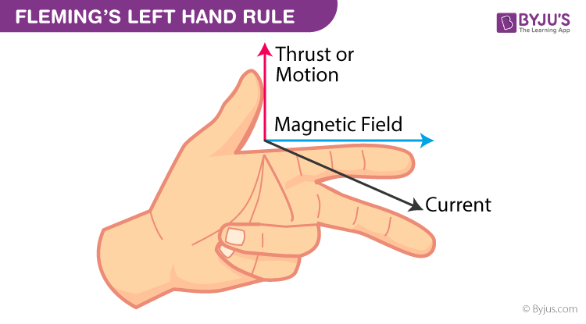

Fig.12.3 Flemings left hand rule

To keep the rotor rotating in a continuous manner, a commutator and brushes are used. The commutator is a rotary electrical switch that connects the stator coil to the power supply in a specific sequence, so that the magnetic field produced by the stator is always in the right direction to exert a torque on the rotor. The brushes are two conductive elements that rub against the commutator, allowing the electrical current to flow from the power source to the stator coil.

The direction of rotation of the motor can be reversed by reversing the polarity of the input voltage or by changing the connection of the brushes to the commutator.

Overall, the simple DC motor works by converting electrical energy into mechanical energy through the interaction of magnetic fields, and it can be used in a wide range of applications, from small household appliances to large industrial machinery.

Equipment/Components:
1. DC motor (Permanent magnet) ……………….2pc
2. DC voltage source………1pc
3. Coupler………………….1pc
4. Multimeter………………1pc

Diagram:

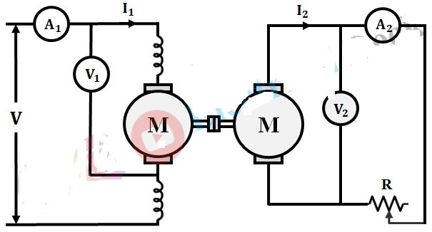

Fig.12.4 Two oppositely coupled DC machine

Procedure:

- Set up the experiment by connecting the two DC motors in opposition to each other. Make sure the polarity of the motors is opposite to each other.
- Connect the multimeter in parallel to the second motor. Set the multimeter to measure voltage.
- Connect the DC power source to the motors. Make sure the voltage of the power source is appropriate for the motors.
- Turn on the power source and observe the voltage reading on the multimeter. The voltage reading should be a small DC voltage.
- Change the direction of one of the motors and observe the voltage reading on the multimeter. The voltage reading should change in polarity.
- Change the speed of one of the motors and observe the voltage reading on the multimeter. The voltage reading should change in magnitude.
- Record your observations and measurements in your lab notebook.
- Repeat the experiment with different voltages and speeds of the motors.
- Analyze your data and draw conclusions about the behavior of the oppositely coupled DC motors in generating voltage.

Data table for DC generator:

DC motor input voltage (Volt) | DC generator output voltage
1
2
3
4
5
6
12

